`Eur-France-Acheulian-Hand-Axe

European Acheulian Lower Paleolithic (ca. 250,000 BP) hand-axe from Le Grand Pressigny France

Perfect, no damage, ancient patination. Length: 4.83 in. (12.26 cm.), Width: 3.33 in. (8.47 cm)

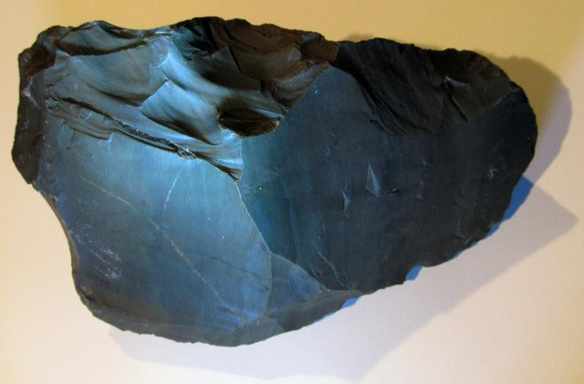

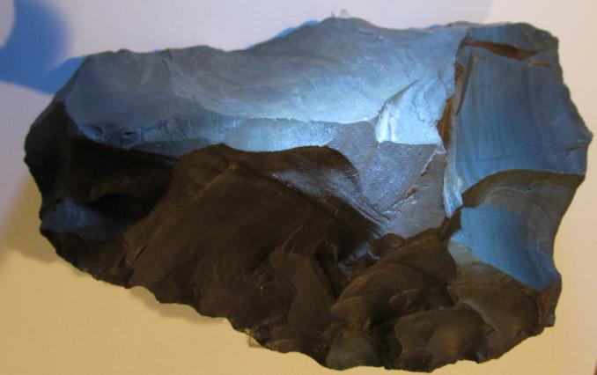

European Acheulian Lower Paleolithic (ca. 250,000 BP) rare unifacial hand-axe of *Homo heidelbergensis* (*Homo erectus*), Le Grand-Pressigny, Southern Touraine, France

This European Acheulian projectile point was fashioned by Homo erectus, the Acheulian method, the predominant tool technology of the Lower Paleolithic, ca. 250,000 years ago.  From an old French collection.

The Acheulian Tradition first began in Africa and there it is well-defined and most diverse when compared to other regions where it eventually diffused.  Although it developed in Africa, the industry is named after the type site of Saint Acheul, now a suburb of Amiens in northern France, where some of the first examples were identified in the 19th century. Acheulian tools are fashioned from large flakes as opposed to using a whole cobblestone as the core.

The edges show extensive retouching to make it sharp on the cutting edge. The actual function of hand-axes is debated.  Some suggest they were not used as a chopping tool but for butchering game, since these tools exhibit wear-use common to butchery.  Based on the varieties of utilitarian hand-axe designs, and not only obvious wear from use but actual well-thought flaking designs to best fit ones hand, there's really little doubt that many of these stone tools were relied on for daily subsistence.

However, there are many tools such as this one that do not exhibit extensive use-wear evidence, and one theory as to why such expertly made tools have been found unworn and in a pristine condition is that the artifact was not used as a tool but as an aid to sexual attraction.  Possibly, males used their stone tool manufacturing techniques to display these symmetrical stone axes as evidence of their superior hunting prowess and thereby to attract females by demonstrating they were the most capable individual for enhanced survival and a better candidate for mating.

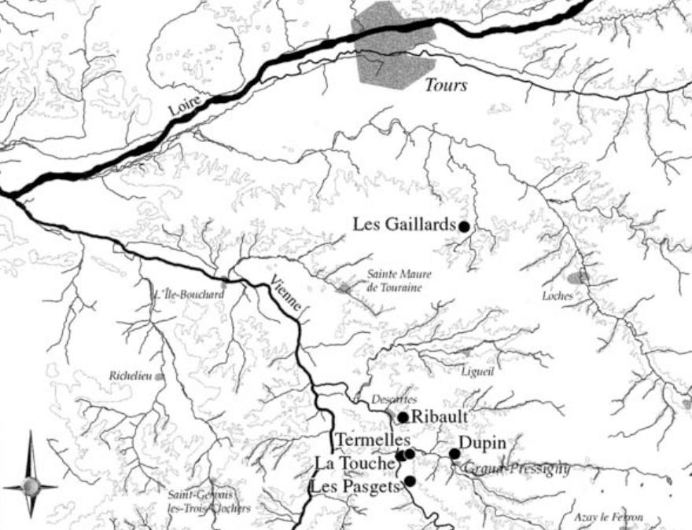

Map of Le Grand Pressigny area, France. After Primault J. 2003. Exploitation et diffusion des silex de la région du Grand-Pressigny au Paléolithique. Ph.D. diss., Université de Nanterre